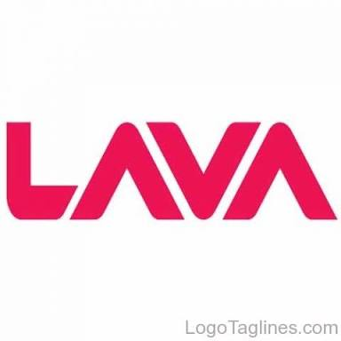
Curriculum Vitae

Name- Karan Gupta
S/O- Shr i Shyam ji Gupta
Address - Lalta Chowk Satna (M.P.) Pin: - 485001
Phone: - 8878888508,8717825535
E-mail I’d.:- karannikhil123@gmail.com
CAREER OBJECTIVE:-
Willing to Work a reputed organization With full devotion, sincerity and honesty up to the best of my capabilities.

QUALIFACTION DETAIL:-
EXAM/ DEGREE | YEAR | UNIVERSITY/BOARD | Percentage
B.com | 2016 | A.P.S.U. Govt. P.G. College Satna | 56%
12 th Board | 2013 | M.P. Board Bhopal | 82%
10 th Board | 2011 | M.P. Board Bhopal | 65%

Currently Working :-

Currently working with “Lava International" Post of
“ARO” ( AreaRetail officer) in Satna. (February 2018 to till)

Previous Working Experience:-
- Worked in“Vivo Industries LTD post of
“SSE.” in Satna.(JUNE 2017 to FEB2018.]

2- worked in “Reliance IndustriesLTD.”(DistributionbyAgrawalTyres) post of
“FOS.” in Satna. (April 2016 to MAY 2017)

3-worked in “Reliance Industries Ltd. Post of “Jio Champ in
Satna.at least “3 months”.(Jan 2016 to 28 March 2016)

4- Worked In  “ICICI Prudential” as a Financial Advisor Satna.[ Feb 2015 to 26 Dec 2015]

PERSONAL SKILLS:-

. Ability to deal with people diplomatically.
. Willingness to work hard and learn.
. Self-motivated.

PERSONAL PROFILE:-
Nationality : Indian
Gender : Male
Date of Birth : 14/10/1995
Status : Unmarried
Father’s Name : Shri Shyam ji Gupta
Permanent Address: Lalta Chowk Satna (M.P.)

Declaration:-
I hereby declare that above information is correct to the best of my knowledge and belief.

Place: -

Karan Gupta

