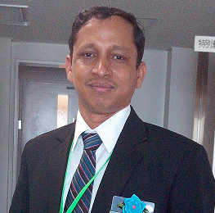

jaswant2727@gmail.com 08791011240
JASWANT KUMAR
Scaling new heights of success with hard work & dedication, targeting senior-level managerial assignments which involve analytical capabilities and professional growth in Manufacturing Operations with a reputed organization preferably in (Electrical/ Auto) industry

Profile Summary
- A goal-oriented professional with 20 years of experience in Manufacturing Operations, Production Planning, Kaizen Activities by establishing an industry revolution with innovative services that expanded market growth; enabled technology that provided great opportunities and revenue growth
- Familiar with working on quality system, online run charts, tracking, application of statistical tools in problem-solving for process improvement;
- Focused on understanding customer demands & providing effective CAPA to customer feedback; enhanced product quality through effective CAPA implementation & analyzing critical process defects by improving assembly efficiency by studying bottlenecks operation & tact time
- Expertise in performing research, designing and modifying manufacturing processes, planning workflow, creating production schedules, estimating production requirements, and coordinating maintenance and repair services
- Directed the execution of manufacturing development projects from conception through production deployment; developed project plans and production schedules, analyzed processes, coordinated resources, supervised project teams, controlled budgets, and managed performance
- Subject matter expert with respect to process development, process transfer and process validation; led technology transfer from product and process development
Soft Skills  Motivational Leader  Change Agent Thinker  Collaborator Planner  Manpower Management Analytical Skills  Communicator    Career Timeline  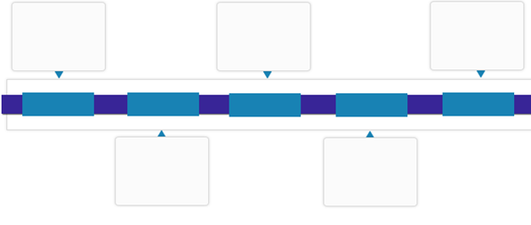  Anchor Electricals Pvt. Ltd., Haridwar  Oswal Electrical Pumps, Karnal  Anco Ltd., Punjab  Raja Forging & Gears Ltd., Baddi  Nov’96-Aug’97  Aug’97-May’01  Aug’01-Mar’03  Mar’03 - Apr’12  Moser Baer India Ltd., Greater Noida | Since Apr’12
  Key Skills
  Production Operations
  Quality Management
  Process Enhancement
  Unit Administration
  Project Management
  Resource Optimization
  New Product Development
  Budgeting, Estimations & Cost Optimization
Work Experience
Since Apr’12 Anchor Electricals Pvt. Ltd., Haridwar
Growth Path:
Apr’12 – Apr’14 Assistant Manager- Production
Apr’14 – Present Deputy Manager (Manufacturing Operations)
Key Result Areas:
- Monitoring and executing projects with respect to budgeted cost, demand forecasts & time overruns to ensure timely execution of the projects
- Conducting cost benefit analysis of the projects including feasibility studies, assessment of the requirements, interface and commissioning
- Monitoring production plan with respect to budgeted cost, demand forecasts, time overruns to ensure timely execution of production as per monthly PSI plan; gathering / executing the information of manufacturing processes such as manpower, material, machine planning
- Estimating plant & machine capacity, allocating planned programme on right machine considering right manpower to achieve quality without forgetting target oriented productivity by executing implementing kaizen activities & improving processes
- Effectuating cost saving initiatives by introducing advance product; achieving cost reduction through value engineering, reduction in breakdown, rework and waste elimination
- Reducing the machine down-time by finding out exact cause like electrical & mechanical troubles and minimising the scrap; conducting preliminary process capability studies for new products or processes
- Monitoring adherence to quality systems, maintaining requisite documents to ensure complete in-process quality & improvement in process capabilities
- Conducting various tests & inspections to ensure that the products developed are in compliance with the pre-set technical specifications
- Focusing on minimizing Q-Loss (internal scrap) by using 7 QC tools like Pareto Chart, Cause & Effect Diagram, Bar Graph, Pie Chart for problem-solving & process optimization on assembly line
- Working towards enhancing manufacturing reliability through 5s, kaizen activities, Kanban, PDCA, waste reduction & POKA YOKE tools

Highlights:
- Accomplished productivity level of 110 parts/ man-day ( Industry best is 100 parts/man-day)
- Executed 12 key projects for quality & productivity improvements. 02 of them honored with bronze medal at QCC Convention- Panasonic Japan
- Steered various quality improvement activities. Reduced defect level from 3.1 % process rejection to 0.7 % in two years
- Worked on “Manpower engagement” as a key project and achieved overall growth by active participation of each & every employee in major activities; enhanced productivity level, 5s on shopfloor, work discipline & gain in CR activities
- Inaugurated new MCB for business growth in FY 13-14
- Directed role in business growth by:
  - Increasing production of new models from development stage onwards. Volume growth 200 % in FY 15-16
  - Managing team of 550 workers & 17 staff members

Mar’03 - Apr’12 Moser Baer India Ltd., Greater Noida
Growth Path:
Mar’03 – Mar’06 Dy. Engineer
Mar’09 – Mar’09 Engineer
Mar’09 – Apr’12 Sr. Engineer
Highlights:
- Directed a team of 65 members to optimize Overall Equipment Effectiveness (OEE)
- Played a key role as a Manufacturing Reliability Trainer by training to all shop floor associates to execute best shop floor practices
- Attained yellow belt certification of Six Sigma terminology adopted by MBIL
- Acknowledged as a team member of Six Sigma Black Belt Project
- Awarded as:
  - Key Resource by M/s Moser Baer India Ltd. since last three years
  - Annual “TIPS Champion for Best Team Work”. TIPS (Teamwork, Integrity, Passion and Speed)
- Played a key role in launching the first production runs of pre-printed disc on new assembly line. A preprinted disc does not require extra printing operation
- Operated on an online scrap reduction project with a team of 3 members. Reduced the scrap from 16 Kg to 2 Kg per line thereby leading to savings of Rs. 18-20 million per annum for the company

Previous Experience
Aug’01-Mar’03 Oswal Electrical Pumps, Karnal as Engineer(Assly Line)

Aug’97-May’01 Anco Ltd., Punjab as Assistant Engineer (Production)

Nov’96-Aug’97 Raja Forging & Gears Ltd., Baddi (HP) as Trainee

Education
- Pursuing AMIE Part –I from Institution of Engineers India, Kolkata
- Diploma in Mechanical Engineering from Govt. Polytechnic, Nilokheri (Karnal), Haryana

Trainings
Attended trainings on:
- PDCA methodology for efficient planning & execution skills
- 7 QC Tools, SPC, SQC, TPM, TQM
- IMS (Integrated Management System i.e. ISO-9001:2007, ISO -14001, ISO-18000
- 5 S & KAIZEN Implementation
- Goal Setting, Communication Skills, Customer Focus and Drive for Results.

Certification
- Yellow Belt/Green Belt Certification - Six Sigma by Moser Bear - Fast Track Methodology
- Train the Trainer; Certified Level 1 Trainer for Manufacturing Reliability

Personal Details
Date of Birth: 24th February 1975
Languages Known: English, Hindi and Punjabi
Current Address: House No.# 7, Near Axis bank, Shankar Colony, Ladwa Road ,Pipli, Kurukshetra (Haryana)- 136118

